Tauranga Girls’ College

Year 11 Mathematics Applied [11MAP], 2020
- This course encourages the
development of numeracy skills.
Numeracy is the bridge between
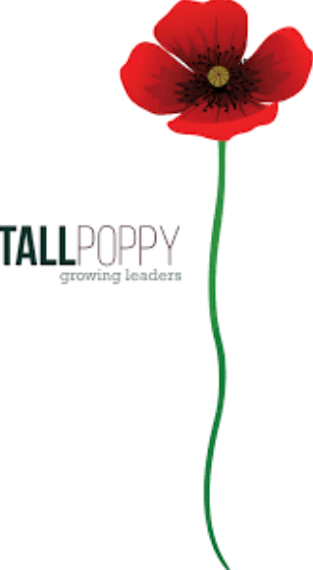
mathematics and daily life. It includes the knowledge and skills needed
to apply mathematics to everyday family and financial matters, learning,
work and community tasks, and social and leisure activities.
- In this course it is possible to achieve the three Numeracy Standards, a
total of 10 credits.
- There will also be opportunity to gain 11 Achievement Standard credits
- The table below shows if the AS contributes towards
Level 1 numeracy and literacy and which Vocational
Pathway the AS may be credited towards. The Vocational
Pathways are: Primary Industries (PI), Service Industries (SI),
Social and Community Services (S&C), Manufacturing and Technology (M&T), Construction and Infrastructure (C&I), and Creative Industries (CI).
- 11MAP leads to the course Year 12 Mathematics Applied [12MAP].

Course Outline:
Term 1 NUMBER: Themes include *Shopping *Spending Money
Term 2 MEASUREMENT: Themes include * Practical measurement
Term 3 STATISTICS: * Use of Census at school data
Term 4 Catch up on Numeracy standards and / or further attempts at Achievement Standards
General:
You require one 1E5 book for notes, a scientific calculator, a ruler, a pen and a pencil. A folder in which to keep a portfolio of your work will be provided. You will also receive a workbook at the start of each term. The total cost of the three workbooks is $10. These workbooks are to be kept in the classroom.

Mathematics is a subject in which ideas build on each other. What you learn one day is needed to understand what comes next. To succeed in Mathematics it is important to attend regularly, bring the required equipment, and complete set work.
If you are absent from class please make sure that you catch up on the work that you have missed.

Assessment:
The Numeracy Unit Standards are awarded on the demonstration of various skills and knowledge. The evidence is collected over a period of time from a range of activities within the learning programme.
The Achievement Standards and the Unit Standards are internal assessments. At least one practice will be completed before each is formally assessed.

Unit Standards to be assessed for NCEA Level 1 are:
TOPIC |  | Credits | Int / Ext | Numeracy/  Literacy & Vocational Pathways | Assessment Week | STUDENT RESULT
NUMBER | 26623  Use number to solve problems | 4 | Int | Core Generic  Work and Study Skills | Portfolio tasks throughout all of Term One
MEASUREMENT | 26627  Use measurement to solve problems | 3 | Int | Core Generic  Work and Study Skills | Portfolio tasks throughout all of Term Two
STATISTICS | 26626  Interpret statistical information for a purpose | 3 | Int | Core Generic  Work and Study Skills | Portfolio tasks throughout all of Term Three
 | Total | 10

Achievement Standards to be assessed for NCEA Level 1 are:
TOPIC |  | Credits | Int / Ext | Numeracy/Literacy & Vocational Pathways | Assessment Week | STUDENT RESULTS
NUMBER (1.1) | [91026 v3] Apply numeric reasoning when solving problems | 4 | Int | Numeracy, C&I, M&T, PI, SI, CI | Internal assessment Term 1 Wk 11  (optional)
MEASUREMENT (1.5) | [91030 v3] Solve measurement problems | 3 | Int | Numeracy, C&I, M&T, PI, SI, S&CS, CI | Internal assessment Term 2 Wk 10  (optional)
STATISTICS (1.10) | [91035 v3] Investigate a given multivariate data set using the statistical enquiry cycle | 4 | Int | Numeracy, Literacy, C&I, M&T, PI, CI | Internal assessment Term 3 Wk 10  (optional)
TERM 4
Reassessment on
AS 1.1, 1.5, 1.10
as needed
 | Total | 11

Have a good year!

