TAURANGA GIRLS’ COLLEGE MATHEMATICS DEPARTMENT

YEAR 9 MATHEMATICS, 2020
Mathematics and Statistics is one of eight learning areas in the New Zealand Curriculum (2007). At Tauranga Girls’ College all students in Years 9 to 11 are required to take Mathematics and most students continue to study Mathematics beyond Year 11.

Topics
Mathematics and Statistics is presented in three strands: Number and Algebra, Geometry and Measurement, and Statistics. It is important to be able to make sense of the many connections within and across these strands.
In Year 9 topics run for a whole term and have content from one or more of the curriculum strands. Each topic also includes problem solving and numeracy skills, which will often be in the context of the curriculum content. An outline of the topics and their assessment is given on the back of this page. Students are encouraged to keep a record of their attainment through the year.

Assessment and Reports
The New Zealand Curriculum identifies students’ level of understanding through eight levels (Level 1 to Level 8) from Year 1 to Year 13, as shown in the diagram below:
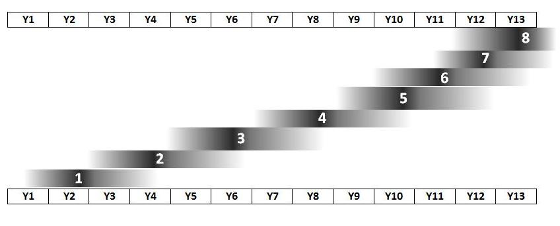
The bars are shaded to show that each student progresses at her own rate, as she is ready. The Levels do not correspond to years at school so the most important thing to look for is progress over time. Year 9 students are assessed at Levels 3, 4 and 5 of the curriculum. (NCEA Level 1, in Year 11, is based on level 6 of the curriculum).
Assessments will record the students’ achievement against the curriculum levels.

Curriculum grades will record the students’ achievement against the curriculum levels. Assessments will require students to recall and apply curriculum skills, thinking and numeracy skills studied through the topic. Each curriculum level is divided into three sub-levels. For example level 3 is split into level 3B (beginning), 3P (proficient) and 3A (advanced).

Students will also be given a tasks grade on their reports which will be a culmination of grades received for tasks and projects they have completed during the term. These assessments will be graded using a NAME (Not achieved, Achieved, Merit, Excellence) scale, as used in NCEA.

Also, each term students are formally given feedback on their progress against three Curriculum Key Competencies (the TGC values): Managing Self, Relating to Others, and Participating and Contributing. Results are recorded as Poor, Inconsistent, Satisfactory, Good, or Excellent.

Equipment and Calculators
Students require two 1E5 maths books with squared paper pages. One exercise book is for notes and one is for class work, tasks and homework. Students will also need a ruler, and a protractor. These can be purchased through their Mathematics teacher. Books and instruments must be brought to class every period. A high standard of presentation and accuracy is expected in both notes and exercise books.

A calculator is not required in this course as an emphasis is placed on using a range of numeracy strategies to develop mathematical thinking and understanding, but calculators may be used as needed and can be use in formal assessments. Should a student wish to use a calculator they must bring their own one.

Homework
A successful way to make progress in Mathematics is to practise the skills and doing homework helps in this regard, so students will regularly be given homework. Homework will include the completion of TGC resource sheets, investigations and projects, reviewing work covered in the current topic, practising problem solving skills, or preparing for the topic test.

There will be numeracy forms online and TGC resource sheets to complete and return for marking on the day set by their teacher. These are designed to regularly review skills from all parts of the Mathematics curriculum and help students identify skills they have not mastered and improve these skills.
Students can also purchase through their teacher the Sigma Fast Track 1 or On Track 1 Homework Books as a further supplement to their classwork. The cost is $18.

Topics and Course Schedule
Topic | Results

Term One:
Pattern and Integers

Term One Portfolio Tasks

Learning Competencies:
Respect, Participation, Pride

Term Two:
Statistics with Fractions and Percentages

Term Two Portfolio Tasks

Learning Competencies:
Respect, Participation, Pride

Term Three:
Measurement and Shape with Decimals

Term Three Portfolio Tasks

Learning Competencies:
Respect, Participation, Pride
Term Four:
Equations and Expressions

Term Four Portfolio Tasks

Learning Competencies:
Respect, Participation, Pride

