**TAURANGA GIRLS COLLEGE Name: _____________**

**YEAR 9 HOMEWORK SHEET Tutor Class: ­­­­­**

**Series A Sheet 2**

*TGC Values: Respect, Participation, Pride* Due Date: ____________

**KEY SKILLS:**

1. In the number 5692 what digit is in the hundreds column? ______
2. Write 2307 in words

____________________

1. Round 734 to the nearest hundred. ­_______
2. Insert < or > to make it a true statement:

547 ­­­____ 291

1. Calculate 72 = ______
2. List the factors of 14

­­­________________

1. Calculate 5 x (3 + 4)

______________

1. 0.7 as a fraction = _____
2. What fraction is shaded?

___________

1.  of 45 = ­­­­______
2. 
3. Write the next two numbers:

11, 7, 3, ____, ____

1. 1 metre = _______ mm
2. What is the *perimeter* of this rectangle?

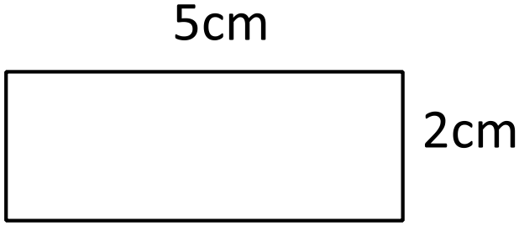

______cm

1. What is the *area* of the rectangle shown above?

______cm2

1. Name this shape:

________________

*Key Skills Total: _____ /* ***16***

**CURRENT WORK:**

1. Which angle is the biggest?

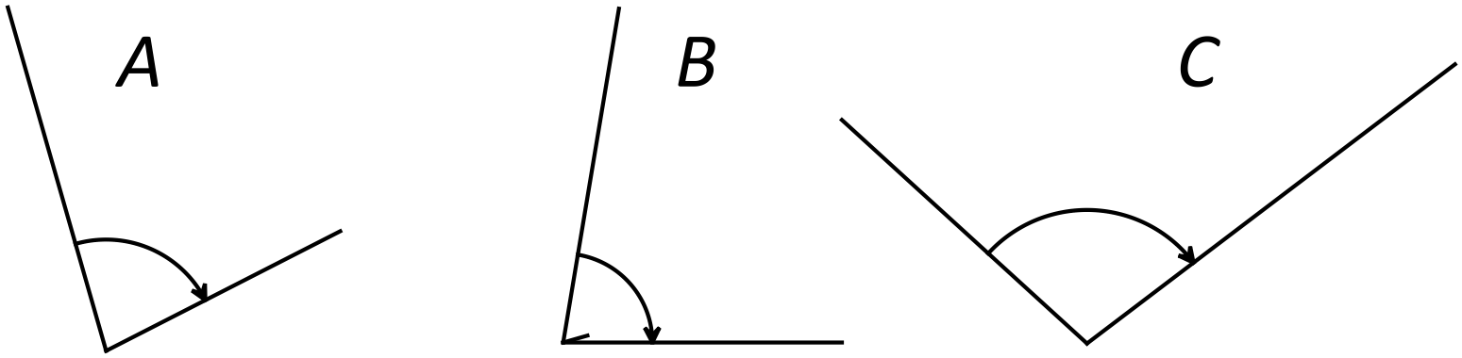________

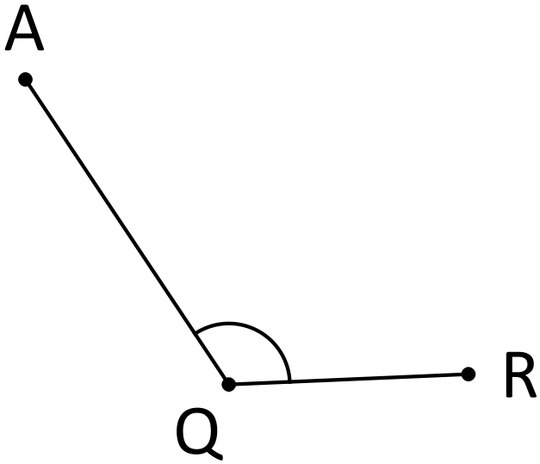

1. Name this angle ___________
2. What type of angle is this? ___________
3. Is this angle bigger or smaller than a right angle?

_________________

Children in Room 2 at Gate Pa School recorded how far they could throw a tennis ball. The distances were taken to the nearest metre. The results are shown below:

C:\Program Files\Microsoft Office\Media\CntCD1\ClipArt7\j0305549.wmf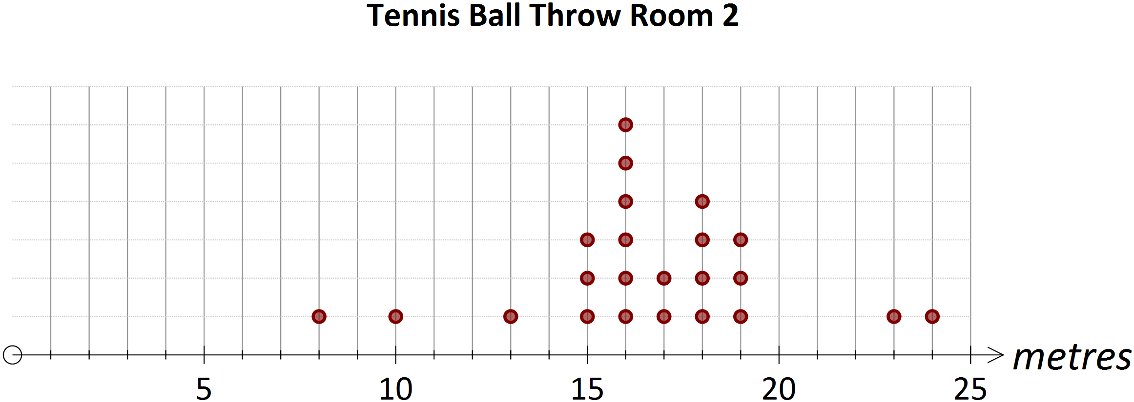

1. What type of graph is this? ________________________
2. How many students threw the tennis ball? __________
3. How many *exceeded* 15m on their throw? ­­­­­__________

*Current Work Total: ______ /* ***7***

**APPLICATIONS AND PROBLEM SOLVING**

These questions require you to use your mathematical skills to solve a problem.

There are three very important things to be aware of:

* Read the question through several times until you know what the question is asking and how you think will go about answering it
* Show your working to show how you solved the question
* Write a clear statement which answers the question

The first questions have given you some working to follow.

When marking give one mark for working and one mark for the correct answer.

1. Linda is collecting cards for her son Max for the Rugby World Cup at Caltex Petrol Stations. On the last three times she has got petrol she has got 27, 43 and 66 stamps. Max needs 200 cards to win a rugby jersey. How many more cards does he need?

Working:

Cards collected = 27 + …………… = ………………..

Cards needed = 200 - ………. = …………..

Max needs _______ more cards.

1. Books are packaged in two different sized boxes. Small boxes hold 20 books. Large boxes hold 50 books. A shipment of books had 6 small boxes and 12 large boxes. How many books was there altogether in the shipment?

Working:

Number in small boxes = 20 x 6 = ……………….

Number in large boxes = …………. X ……………… = ……………….

Total = ……………….. + …………………

There are _______ books altogether.

1. Fred works 8 hours a day on Monday, Wednesday and Friday, and on Tuesday, Thursday and Saturday he works 5 hours a day.

If he is paid $20 for every hour he works, how much will he get paid each week?

Working: (Show your working and you set it out as shown above)

1. There are 10 rows of Year 9 students in the hall and there are 15 students in each row. There are 11 rows of Year 10 students and each row has 12 students. If the rows are all full, which year group has the most students, and by how many?

Working:

Answer: Year ___ has _____ more students than Year ___ .

*Applications and problem solving Total: ______ /* ***8***

***Self Reflection:***

|  |  |  |
| --- | --- | --- |
|  |  | ***Comment (What do I need to understand?)*** |
| ***Key Skills*** | ***___ / 16*** |  |
| ***Current work*** | ***___ / 7*** |  |
| ***Applications*** | ***___ / 8*** |  |
| ***Total*** | ***___ /31*** |  |