TAURANGA GIRLS COLLEGE Name: _____________
YEAR 9 HOMEWORK SHEET Tutor Class:
Series A Sheet 3
TGC Values: Respect, Participation, Pride Due Date: ____________

KEY SKILLS:

- In the number 4562 what digit is in the tens column? ______

- Write 4007 in words
____________________

- Round 7394 to the nearest thousand
_______________

- Insert < or > to make it a true statement:
5472 ____ 5291
- Calculate 9² = ______

- List the factors of 10

__________________

- Calculate 2 + 3 x 5

__________________

- Write 0.9 as a fraction = _____

- What fraction is shaded?
___________

- of 32 = ______

- Write the next two numbers:
16, 11, 6, ____, ____

- 1 kilometre = _______ m

- What is the perimeter of this rectangle?
______cm

- What is the area of the rectangle shown above?

______cm²

- Name this shape:

_________________

Key Skills Total: _____ / 16

CURRENT WORK:
Answer the questions below using angles 1 to 4

- Name Angle 2 ________

- What type of angle is Angle 4? ________

- Use your protractor to find the size of each angle:

Angle 1 ______ Angle 2 ______ Angle 3 ______ Angle 4 _____

- What is a reflex angle?

- If a wheel turns through five complete revolutions how many right angles has it turned through?

Current Work Total: ______ / 8
APPLICATIONS AND PROBLEM SOLVING
(Show your working to show how you solved these questions. One mark for working, one mark for the correct answer)
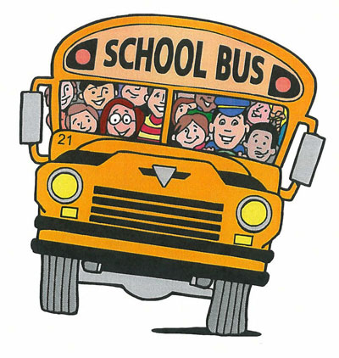
- There were 452 students in a school and 218 of them caught the school bus. How many of the students in the school did not come to school by bus?

Working:

Answer: ________ students do not come to school by bus.
- In the month of September this year the first Sunday is on the 2nd of September. If you add the numbers of the Sundays in September this year what total will you get?

Working:

Answer: The dates will total to ________

- Jemima was counting how long is was until her birthday.
Her Mum told her that it was 13 weeks and 4 days until her birthday.
How many days are there until Jemima’s birthday?

Working:

Answer: There are ______ days until Jemima’s birthday

- In the months of March, April, May and June there are 31, 30, 31 and 30 days respectively. In a year of 365 days how many days are there in total in the other eight months?

Working:

Answer: There are ______ days in the other eight months.

Applications and problem solving Total: ______ / 8

Self Reflection:
 |  | Comment (What do I need to understand?)
Key Skills | ___ / 16
Current work | ___ / 8
Applications | ___ / 8
Total | ___ /32

