**TAURANGA GIRLS COLLEGE Name: _____________**

**YEAR 9 HOMEWORK SHEET Tutor Class: ­­­­­**

**Series A Sheet 1**

*TGC Values: Respect, Participation, Pride* Due Date: _____________

**KEY SKILLS:**

1. In the number 3902 what digit is in the *hundreds* column? ______
2. Write 237 in words

____________________

1. Round 347 to the nearest hundred. ­_______
2. Insert < or > to make it a true statement

154 ­­­ ____ 89

1. Calculate 62 = ______
2. List the factors of 6

_____­­­­­__________

1. Calculate (2 + 3) x 6

___________

1. Write 0.3 as a fraction = _____
2. What fraction is shaded?

___________

1.  of 30 = ­­­­______
2. 
3. Write the next two numbers in this sequence:

11, 8, 5, ____, ____

1. 1 metre = _______ cm
2. What is the *perimeter* of this rectangle?

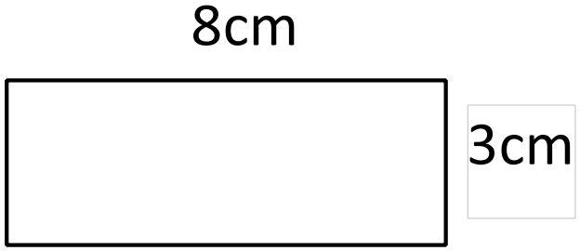

______cm

1. What is the *area* of the rectangle shown above?

______cm2

1. Name this shape:

___________________

*Key Skills Total: _____ /* ***16***

**CURRENT WORK:**

1. Which angle is the biggest?

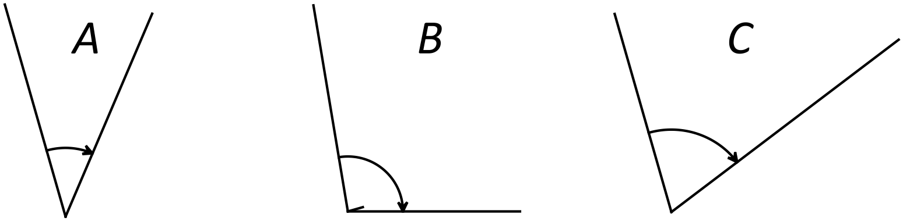________

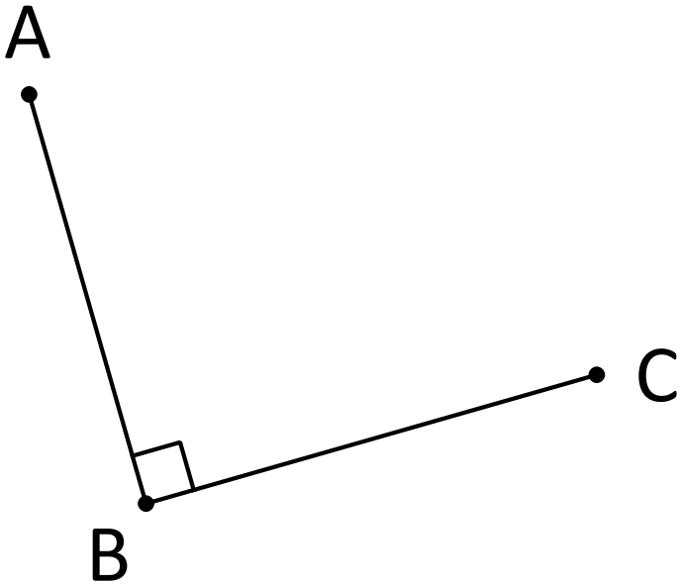

1. *Name* this angle ___________
2. What *type* of angle is this? ___________
3. How many *degrees* in this angle? _____

Children in Room 1 at Gate Pa School recorded how far they could throw a tennis ball. The distances were taken to the nearest metre. The results are shown below:

C:\Program Files\Microsoft Office\Media\CntCD1\ClipArt7\j0305549.wmf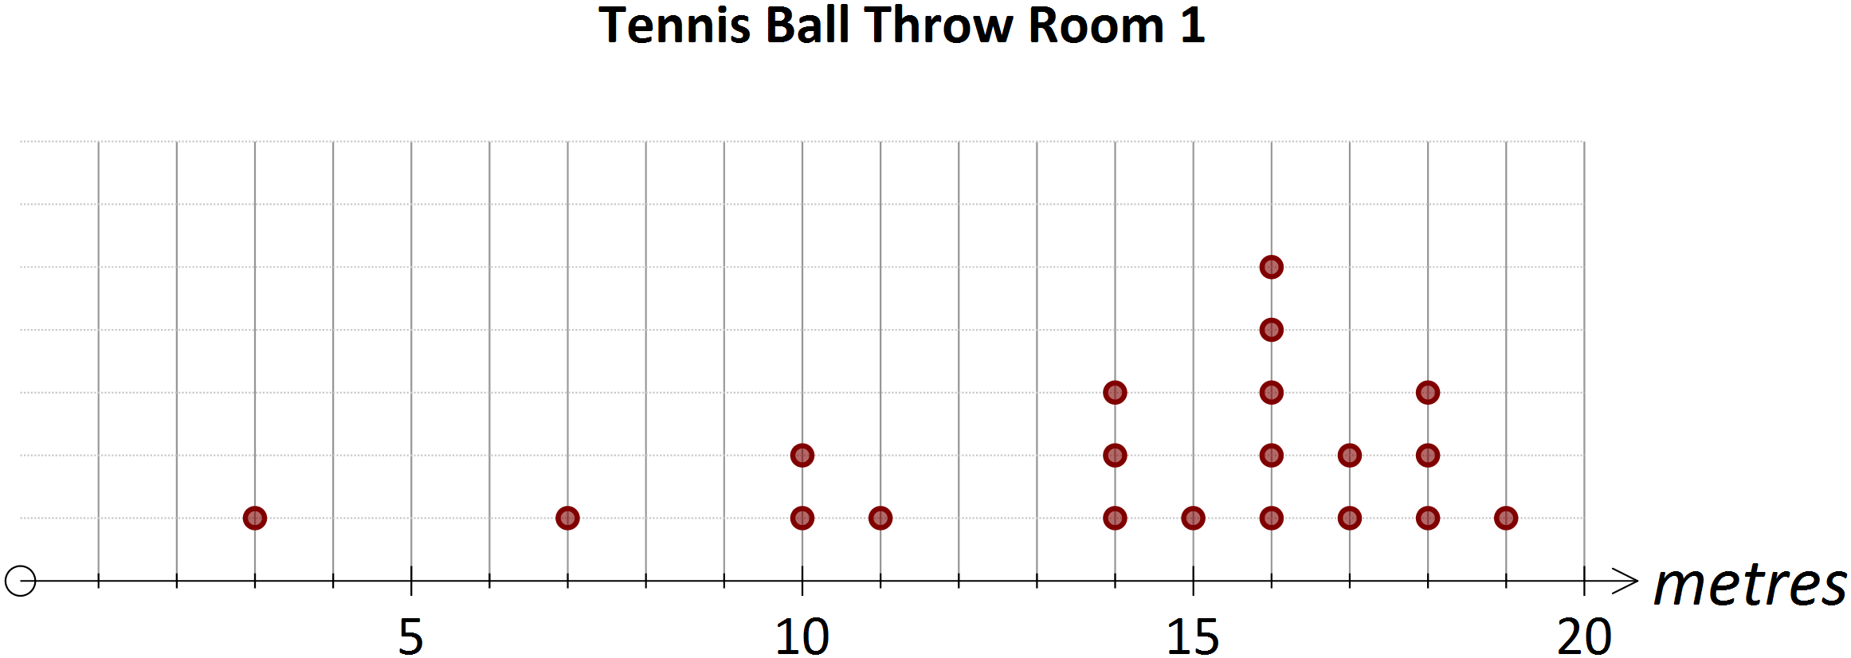

1. What type of graph is this? ________________________
2. What was the longest throw? __________
3. How many threw over 15m? __________

*Current Work Total: ______ /* ***7***

**APPLICATIONS AND PROBLEM SOLVING**

These questions require you to use your mathematical skills to solve a problem.

There are three very important things to be aware of:

* Read the question through several times until you know what the question is asking and how you think will go about answering it
* Show your working to show how you solved the question
* Write a clear statement which answers the question

The first questions have given you some working to follow.

When marking give one mark for working and one mark for the correct answer.

C:\Program Files\Microsoft Office\Media\CntCD1\ClipArt2\j0215907.wmf

1. Louise is collecting stamps for the Countdown bonus reward. On the last three times she has gone shopping she has got 21, 16 and 36 stamps. She needs 100 stamps to get the reward. How many more stamps does she need?

Working:

Stamps collected = 21 + 16 + …………… = ………………..

Stamps needed = 100 - ………. = …………..

Louise needs _______ more stamps.

1. Louise is saving money to buy a new phone that costs $550. She has saved $180 and her Gran gave her $100. How much more money does Louise have to save to be able to buy the phone?

Working:

Louise has ……………… + ………………….. = …………………….

Amount left = $550 - …………………….. = ………………….

Louise needs $ _______ more to buy the phone..

1. Pencils come in packs of 20. Pens come in packs of 30. Richard bought 6 packs of pencils and 5 packs of pens. How many pens and pencils did he have altogether?

Working:

Number of pencils = 20 x 6 = ……………….

Number of pens = …………. X ……………… = ……………….

Total = ……………….. + …………………

Richard has _______ pens and pencils altogether

1. The number of hours Freda works each day varies from day to day. On Monday, Wednesday and Friday she works 8 hours a day. On Tuesday, Thursday and Saturday she works 5 hours a day. Hours many hours in total does she work in three weeks?

Working: (Show your working and you set it out as shown above)

Answer: Freda works _______ hours in total.

*Applications and problem solving Total: ______ /* ***8***

***Self Reflection:***

|  |  |  |
| --- | --- | --- |
|  |  | ***Comment (What do I need to understand?)*** |
| ***Key Skills*** | ***___ / 16*** |  |
| ***Current work*** | ***___ / 7*** |  |
| ***Applications*** | ***___ / 8*** |  |
| ***Total*** | ***___ /31*** |  |

***Parent Signature: _____________***