TAURANGA GIRLS COLLEGE Name: _____________
YEAR 9 HOMEWORK SHEET Tutor Class:
Series A Sheet 4
TGC Values: Respect, Participation, Pride Due Date: ____________

KEY SKILLS:

- In the number 43,562 what digit is in the thousands column? ______

- Write 40,000 in words
____________________

- Round 5794 to the nearest thousand
_______________

- Insert < or > to make it a true statement:
5672 ____ 5341

- Calculate 11² = ______

- List the factors of 12

__________________

- Calculate (2 + 3) x 5
__________________
- Write 0.1 as a fraction = _____

- What fraction is shaded?
___________

- of 27 = ______
- Write the next two numbers:
17, 12, 7, ____, ____

- 1 centimetre = _______ mm

- What is the perimeter of this rectangle?
______cm

- What is the area of the rectangle shown above?

______cm²

- Name this shape:
(all sides are equal length)

__________

Key Skills Total: _____ / 16

CURRENT WORK:
Answer questions 1 to 4 below using angles 1 to 2

- Name Angle 2 ________

- What type of angle is Angle 1? ________

- If a wheel turns through eight complete revolutions
how many right angles has it turned through? _____________

- Complete each of the following sentences:
  - Vertically opposite angles are ____________
  - Angles on a straight line add to __________ degrees
  - Angles at a point add to __________ degrees
  - Angles in a triangle add to __________ degrees

- Give the size of each angle below (do not use a protractor)

a = _____ b = _____ c = _____

Current Work Total: ______ / 10
APPLICATIONS AND PROBLEM SOLVING
(Show your working to show how you solved these questions. One mark for working, one mark for the correct answer)
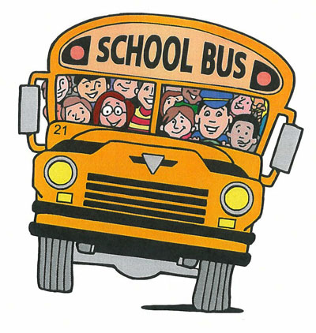
- There were 1356 students in a school and 818 of them caught the school bus. How many of the students in the school did not come to school by bus?

Working:

Answer: ________ students do not come to school by bus.

- In a small school all Year 9 go to camp. To go to camp they take two buses, each taking 55 students; plus eight cars each taking 4 students; plus two minivans each taking 11 students. How many students went to camp?
Working:

Answer: ________ Year 9 students went to camp.

- Shona is picking passion fruit and putting the pulp in 500g containers. If she gets 320g and 465g on the first two days of picking how much more pulp is needed to full two containers?

Working:

Answer: Shona needs ______ more grams of pulp.

- Shona sells the passion fruit in 500g and 200g containers.
The 500g containers sell for $5 each and the 200g containers for $2 each.
Shona goes to the Tauranga Primary School Market day and sells twenty 500g containers and fifteen 200g containers.
How much money does she get in total from her sales?

Working:

Answer: Shona needs ______ more grams of pulp.

Applications and problem solving Total: ______ / 8
Self Reflection:
 |  | Comment (What do I need to understand?)
Key Skills | ___ / 16
Current work | ___ / 10
Applications | ___ / 8
Total | ___ /31

